Call for Papers on ICCMIT2019

Advances in Signal and Image Processing, Coding, Analysis and Recognition - 2019 (ASIPCAR-19)

Organized by:
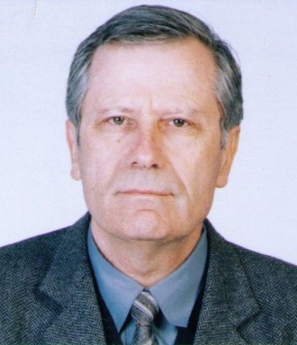
Prof. Roumen Kountchev, Ph.D., D.Sc.

Technical University of Sofia, Bulgaria
E-mail: rkountch@tu-sofia.bg

Objectives and Motivation
The intensive development of the information technologies opened wide opportunities for the development of new approaches, methods, algorithms and systems for processing of various kinds of multidimensional signals and images, and also - for applications aimed at their compression, analysis and encryption, and at the recognition of multidimensional objects and their search in large image databases. The offered methods and algorithms in these application areas will open new ways for their business applications and will serve as a basis for the future development of the computer technologies.
In this session can be presented investigations related to processing, coding, analysis, and recognition of various medical signals and images, audio signals, hydro-, radio location and seismic signals, image sequences got from TV-, aero- and satellite systems, drones, surveillance systems, multi-view images, etc.
In the topics of this session are also welcome presentations of new methods, algorithms and systems for encryption of medical and audio signals, and images of various kind (static, or sequences), and also - contemporary tools for their content protection.

Scope and Interests (not limited to)
- Processing, analysis and encoding of audio signals
- Processing, analysis and encoding of medical signals
- Processing of radar, hydro location, seismic and optic signals
- Processing, analysis and coding of medical images
- Processing and analysis of microscopic images
- Processing, analysis and coding of photo and TV images
- Models for the representation of multidimensional signals and image sequences
- Statistical analysis of signals and images
- Processing, analysis and coding of multi- and hyper spectral images
- Processing, analysis and coding of ultrasound and thermal images
- Processing, analysis and coding of multi-view images
- Encryption and watermarking of one-dimensional signals
- Coding and watermarking of multidimensional signals and images
- Compression of audio signals and images
- Analysis of spectroscopic images
- Extraction and evaluation of features which characterize signals and images
- Objects recognition in images
- Objects search in image databases
- Architectures for processing of signals and images in various application areas
- Computer vision systems
- Surveillance systems
- Intelligent Internet-based video systems
- Systems for multimedia information
- Systems for X-ray defectoscopy
- Audio and video communication systems and networks

Paper Submission
We invite authors to submit original and high quality articles on the abovementioned topics (which are not limited to) to Prof. Roumen Kountchev (session chair) rkountch@tu-sofia.bg

All instructions and templates for submission can be found in the ICCMIT2019 website:
http://www.iccmit.net/

The accepted papers will be published in ISI/SCOPUS journals. Also, the best articles will be invited to be published as extended article/ book chapter in IGI Book.

Important Dates
Paper abstract submission: February 10, 2019
Notification of acceptance: February 20, 2019
Final paper submission and author’s camera ready: March 03, 2019
Conference Dates: March, 2019

