Special Session Proposal
Special Session: Recent Trends in Computer Networks and Wireless Communication
Session Chairperson: Prof. (Dr.) Atul M. Gonsai, Professor of Computer Science, Department of computer Science, Saurashtra University, Rajkot-360005 Gujarat, India.
Aim: The main objective of this special session is to present the research from different areas of Computer Networks and Wireless Communication. This special session provides a platform for researchers and scientists across the world to exchange and share their experiences and research results about all aspects of electronics and information technology. This special session also provides an opportunity to interact and establish professional relations for future collaboration. The special session aims to promote innovations and work of researchers, engineers, students and scientists from across the world on Advancement in Computer Networks and Wireless Communication. The basic idea of the special session is what more can be done using the existing technology. In Today’s world Computer Networks and Wireless Communication plays an important role for future’s innovation.
Areas of Coverage (sub-themes)
The areas of coverage for this special session are:
- Communication & Network
- Mobile ad-hoc networks,
- Coding and Diversity,
- Multicarrier Communication Systems,
- Next generation networking and wireless systems,
- Routing protocols and QoS,
- Cooperative communications,
- Secure communications and Cryptography,
- Space-Time Codes,
- MIMO and Adaptive antennas,
- Multimedia Information Systems,
- Parallel and Distributed Systems,
- Wireless Sensor Networks,
- Optical Wireless and Communications,
Submit your original research paper on https://easychair.org/conferences/?conf=icgcet18 and also send on email of chair of special session i.e. amgosai@sauuni.ernet.in

Session Chairperson Details

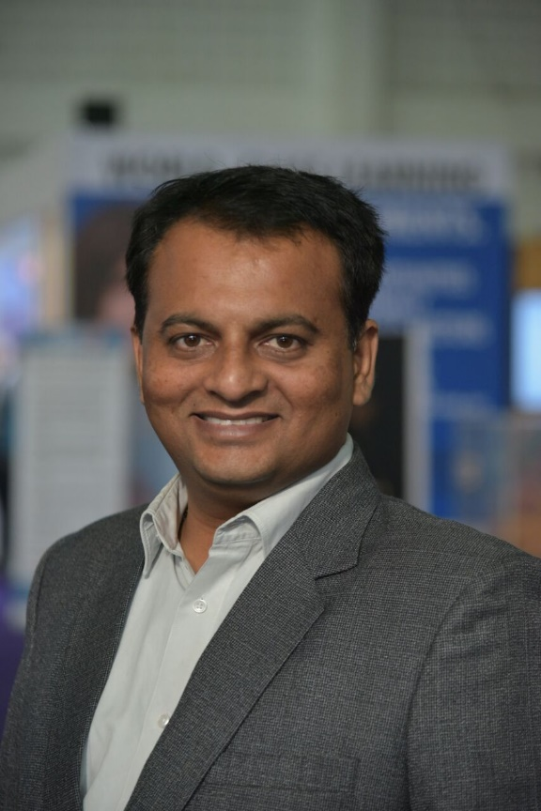
https://sites.google.com/site/atulgosai/

Dr. Atul Gonsai, Ph.D., MCA, BBA is Professor of Department of Computer Science, Saurashtra University, Rajkot. Atul Gosai has received his Ph. D degree in the field of Computer Science from the same University. He has also completed Master of Computer Applications (MCA) from the same Department in April 2000. He has total teaching experience of Seventeen years. He has been awarded the "CAREER AWARD FOR YOUNG TEACHERS” from ALL INDIA COUNCIL FOR TECHNICAL EDUCATION (AICTE) New Delhi with amount of Rs. 10.5 lakhs. He has been teaching subjects like UNIX/ Linux Concepts and Shell Programming, C Programming and Data Structure, Networking and Advanced Networking, Network Programming, Java and C# Dot Net.

He is the author of Eight books and over 97 research papers related to computer science and computer networking in International and National Journals and conferences. His research interest encompasses performance tuning of computer networks, wireless networks, High performance networking, Rate Control Protocol (RCP), Encryption, Cloud computing etc. He has taken part in 26 national and 15 international conferences and seminars. He has visited 8 Countries for Research and Extensions Activities. He has Completed 4 Research Projects and One form UGC major is Ongoing amounting Rs11.10lakhs. He has rendered services as a reviewer for 12 journals and 8 conferences. He has worked as an expert for more than 61 different activities. He has delivered 9 TV/Radio Talks 5 International lectures and 17 Invited lectures. He has been sponsored by British Council, European Union Erasmus+ and Russian Academy of Science and North easterns Federal University Yakutsk, Russia. He got selected by Microsoft for training on networking and wireless networking at IISC Bangalore. He is Associate fellow of UGC-IIAS Shimala. He is DCNI, D - link Certified Network Integrator from D-link India Goa. He is maintaining and handling MCA computer Labs and Saurashtra University Library Networking. He is life Member of ACM,CSI,ISTE, IETE and other 20 professional bodies.He is also coordinating the International relations and International Students Cell (ISC) of Saurashtra University.

Contact Details
E-Mail: amgosai@sauuni.ernet.in
Mobile: +919427236866
Last Date of Paper Submission: 15th May2017
Paper Acceptance Notification: 15th June 2017

